ECA - 5610 5G/6G Communication Systems
NAME : Mohit V 192512043 DATE : 01/08/2026
Ex.No. 2: Implementing TDMA Slot Allocation in GSM.
Aim : To implement TDMA (Time Division Multiple Access) slot allocation in GSM using
MATLAB and analyze system performance in terms of time slot duration, frame utilization,
and number of allocated slots.
Objective:
1. To calculate the Time Slot Duration in a GSM TDMA frame by dividing the total frame
time into equal time slots. This helps in understanding the time structure of GSM
communication.
2. To determine the Frame Utilization (%) based on the number of allocated time slots
compared to total available slots. This evaluates the efficiency of TDMA resource usage.
3. To compute the Number of Allocated Time Slots for multiple users in the GSM system.
This ensures proper scheduling and interference-free communication.
Procedure:
1. Define GSM frame parameters such as total frame duration and number of time slots.
2. Compute time slot duration by dividing frame duration by number of slots.
3. Assign time slots to multiple users based on availability.
4. Calculate frame utilization percentage using allocated slots vs total slots.
5. Determine total number of allocated slots for active users.
6. Plot time slot allocation and utilization using MATLAB graphs.
7. Display results in the command window for analysis.

OUTPUT AND RESULT
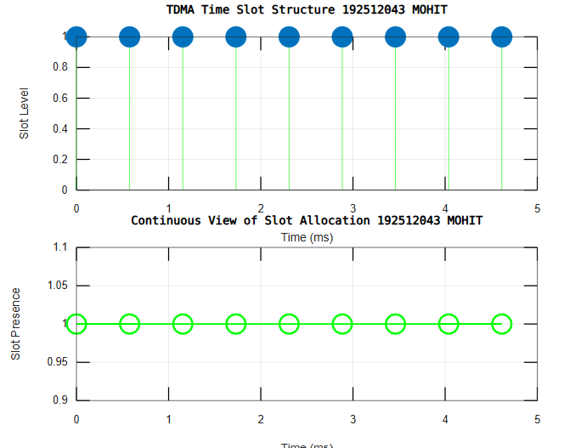
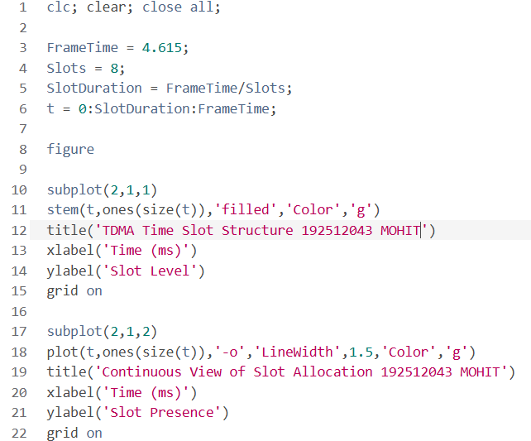
OBJECTIVE 1:

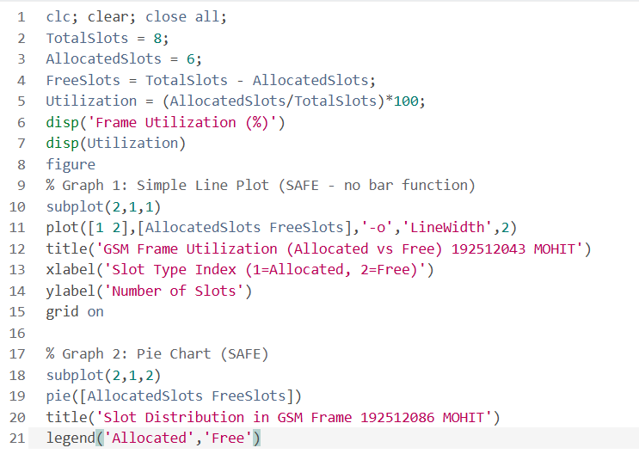
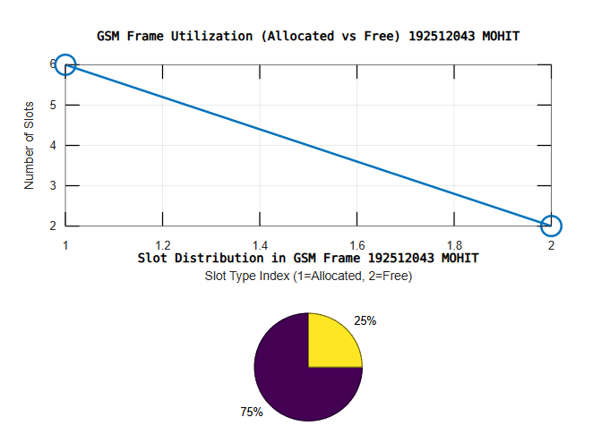
OBJECTIVE 2:

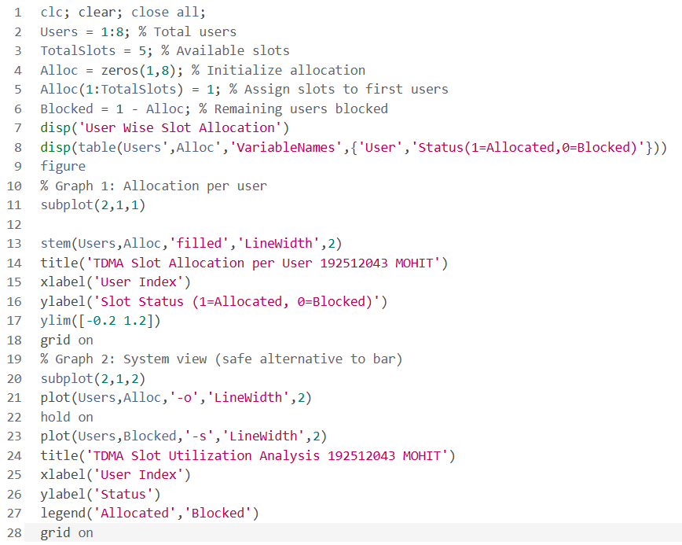
OBJECTIVE 3:
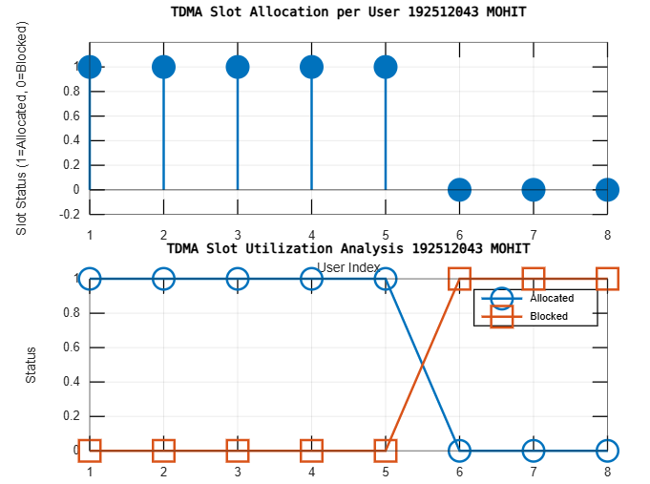

Result:
1. The time slot duration in the GSM TDMA frame was successfully calculated, confirming
equal division of the frame into fixed time intervals.
2. The frame utilization was effectively analyzed, showing the proportion of allocated and
free slots in the TDMA system.
3. The slot allocation per user was successfully implemented, demonstrating that limited
slots are assigned to users while excess users are blocked due to resource constraints.

